Where to get help  If you need help of someone to talk to about anything, these are the people that you can rely on:  Our Parents  Teachers  Support Staff  A Trusted Adult  You can go and talk with your teacher if you need help, especially about friendships. Your teacher can help if you are finding some things difficult to cope with on your own.  If you feel that you can’t speak to an adult there is always a friend in your class to help you. You should always speak to someone if you need help, don’t keep it inside.  We want you to be and feel safe and you can call this number if you need help or advice.  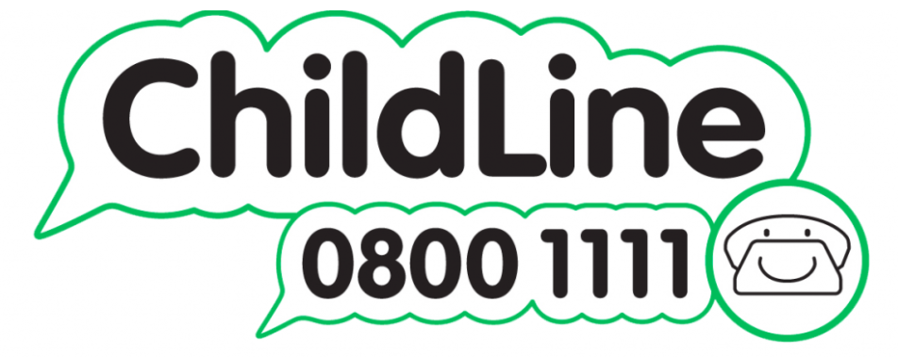 | 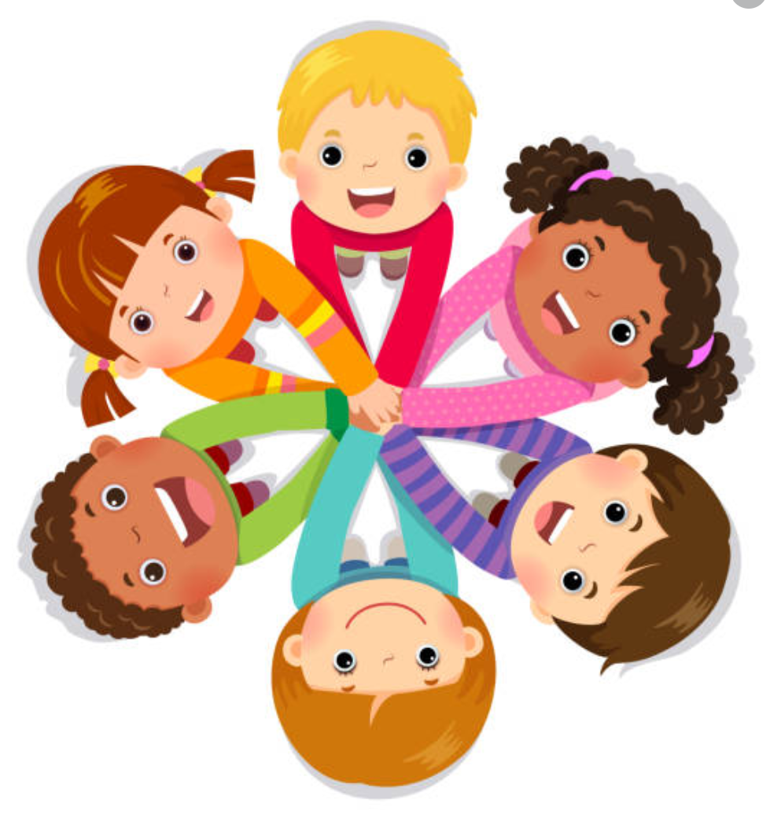  Rules to remember in our lessons  - Be kind and supportive to others  - Laugh with one another but not at each other  - Listen by looking at each other and not interrupting  - Respect each other’s views and feelings  - Join in a discussion if you feel comfortable  - Sometimes what we learn is private and should not be discussed with younger children | Victoria Community School  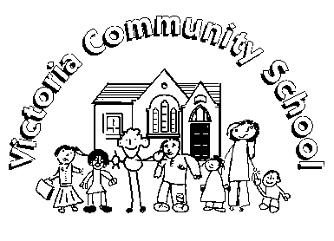  RSE in our school
Why do we have RSE lessons in pshe?  Lessons in PSHE help us to understand our bodies as we grow and change. You have already changed a lot since you were in Nursery!  The adults that look after us at home may not feel comfortable to talk with us about relationships and body changes. We can learn about these things at school and talk about them at home, afterwards.  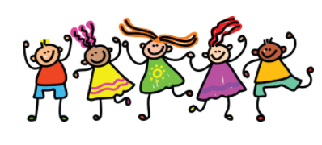  Our PSHE lessons give us skills that we can use to cope with difficult situations. We learn about drugs, alcohol and tobacco, keeping healthy, how to look after our emotional and mental health, relationships and how our body changes as we get older. We also have lessons to learn about peer pressure and how to identify things that are dangerous and unsafe. | What does it look like?  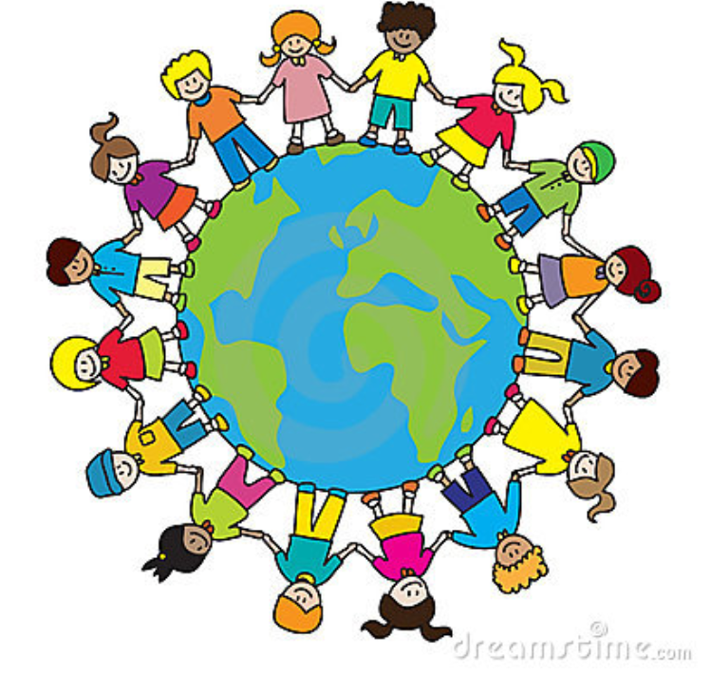  We learn that boys and girls can be anything they want to be and they can accomplish their dreams. We can all enjoy playing sports, drawing and dancing. Boys and girls can have any job they choose.  RSE in KS1  We learn about male and female animals and their lifecycles.  We talk about how boys’ and girls’ bodies are different and how they change from being a baby to an adult.  We learn the correct words for different parts of the body. | RSE in KS2  We will recognise differences between boys and girls and learn names for parts of the body.  We explore the changes that will happen to our bodies as we grow and change.  Boys and girls will sometimes have different lessons in this topic so that the children will feel more comfortable.  We will recognise that there are different types of families.  We will discuss the importance of positive friendships.  We learn that families are special.  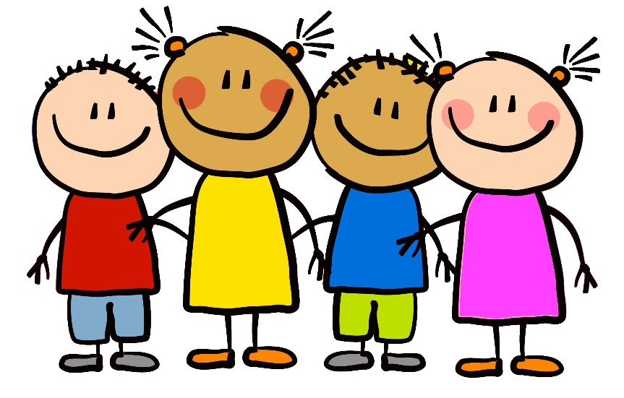  We learn how to make friends.

